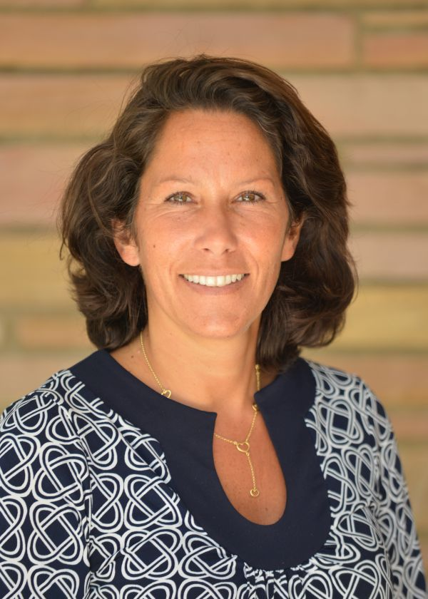
Karine gaultier
Conseillère Orientation
Tel: 301-530-8260 ext 254
Email: gaultierk@rochambeau.org

Karine Gaultier has been a guidance counselor at the Lycée Rochambeau since September 2009.
With a double Masters in Human Resources from Preparatory class HEC Business School and IEP Bordeaux, Karine started her carreer at Michael Page (in Paris and Barcelona), where she worked as a Recruitment Consultant for 8 years. As a Regional Director, she met hundreds of applicants and CEOs in different sectors of activity. Karine also created her consulting company in Barcelona that she ran until her arrival in the U.S.Karine's professional experience allows her to understand the responsibilities of guidance counselors with the perspective and pragmatism of the professional world.

