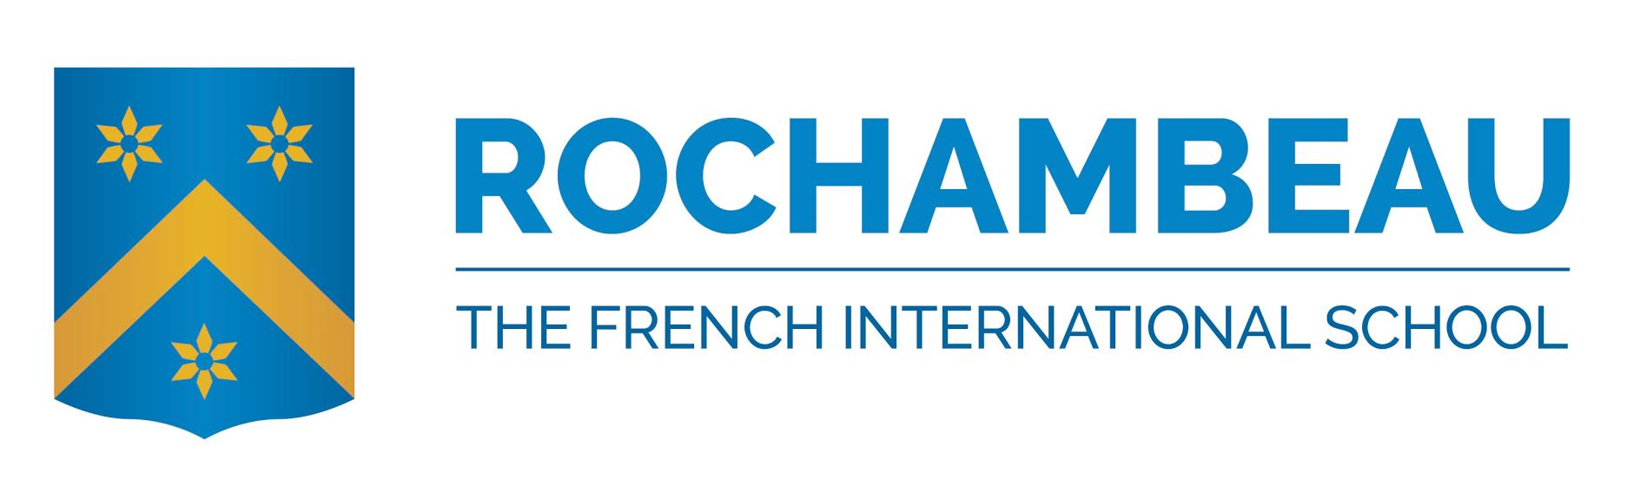
PSAT INFORMATION 2016

WHO?
- Students in première who are interested in studying at US universities are encouraged to take the PSAT. (Secondes will be able to take the PSAT 10 in late Feb/early March.)

WHY?
- The PSAT provides excellent practice for the SAT (a required test for many US universities). You will receive a score and a report on how you can improve your score. Universities do NOT receive these scores.
- For US citizens and permanent residents, a very high score can qualify you for scholarship money at some universities. You must also plan to stay at Rochambeau for your final year of the Bac in order to qualify for the scholarships.

WHEN?
- Wednesday, October 19, 2015 from 8:00am to 12:00pm (approximately)

WHERE?
- Lycée auditorium

HOW LONG?
- The actual testing time for the PSAT is two hours and 45 minutes, plus 10 minutes for breaks. Distribution of materials/filling out personal information on sheets can take up to one hour. There are sections of math and verbal/critical reading, or “evidence-based reading and writing,” questions.

HOW? To register for the PSAT:
- Complete the attached registration form. Be sure to include your email addresses and your check for the fee ($23.00). Make checks payable to Rochambeau.
- You must register no later than Tuesday, October 11. Return the form and your check to the receptionist at the administration building, Forest Road campus, between 8am and 5:30pm.

HOW DO I PREPARE?
- Pick up a free practice test booklet when you turn in your registration
- Consider taking a free practice PSAT at PrepMatters in Bethesda or McLean on a Saturday or Sunday: http://www.prepmatters.com/practicetests
- Kaplan Test Prep offers free practice PSATs: http://www.kaptest.com/enroll/PSAT/20814/events
- See the College Board’s website for more information: http://www.collegeboard.com/student/testing/psat/about.html

WHAT DO I BRING on the test day?
- Dark pencils
- Erasers
- Calculator (see PSAT booklet for the type of calculator allowed)

